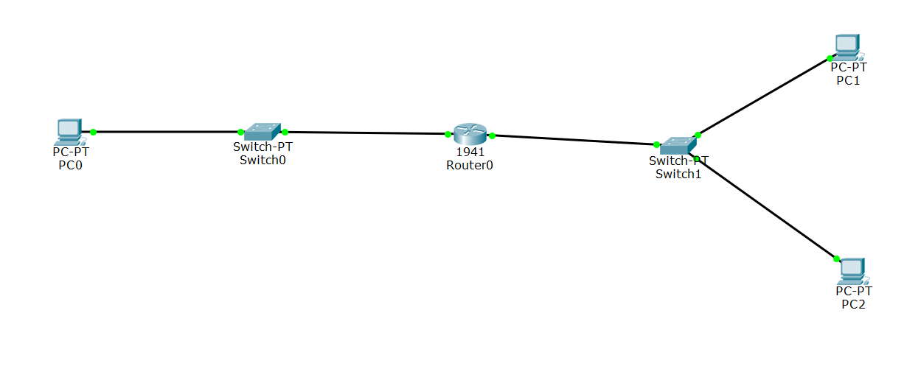
1- From PC1 ping PC2 , since they are in the same local network then you can use the Link Local Address (See PC1>>Desktop>>IP configuration>> IPv6 configuration>> Link Local Address)
2- Go to the router and from CLI type this command
Router(config)#ipv6 unicast-routing
Router(config)# interface GigabitEthernet0/0
Router(config-if)#ipv6 address FE80::1 link-local
Router(config-if)#no shut

Then the second interface from the same CLI .....
Router(config)# interface GigabitEthernet0/1
Router(config-if)#ipv6 address FE80::1 link-local
Router(config-if)#no shut

3- From PC2 ping the gateway - router - (ping FE80::1 )
4- From PC0 ping the gateway - router - (ping FE80::1 )

Can PC0 ping PC2 ??
No
Beacuse the local network addresses are only significant on local nework
Proof: from PC0 ping PC2

