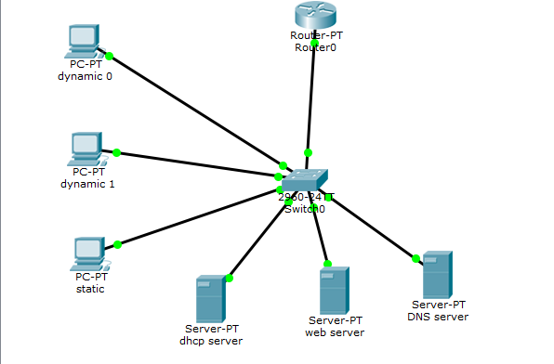

Put a router (Generic ) router –PT
Put a switch ( 2960 )
Put 3 PCs and 3 Servers
Connect them all using cooper straight
1)Go to the router and change the IP configuration :
IP Address: 192.168.1.1
Subnet Mask: 255.255.255.0
Port Status: ON

2) Then go to the server 0 ( name it DHCP Server)
Configure the IP from desktop
IP address: 192.168.1.2
Subnet mask: 255.255.255.0
Default gateway: 192.168.1.1
Then choose from services DHCP
Press on
Gateway: 192.168.1.1
DNS : 192.168.1.4

3) Go to the server 1 ( name it Web Server)
Configure the IP from the desktop
IP address: 192.168.1.3
Subnet mask: 255.255.255.0
Gateway: 192.168.1.1
Go to service and choose HTTP
On the box write
Pnu.com : )
Like below:
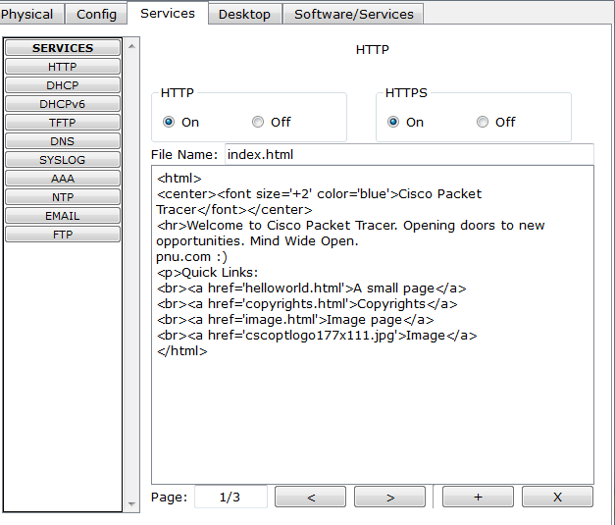
4) Then go to server 2 (name it DNS Server)
Configure the IP from the desktop
IP address: 192.168.1.4
Subnet mask: 255.255.255.0
Default gateway: 192.168.1.1
Go to DNS from service
Press on
Type pnu.com in the Name
Type the address 192.168.1.3
Then press add

5) Then go the pc 0 ( name dynamic 0)
Choose DHCP
And also pc 1 (name it dynamic 1) choose DHCP
For PC2 ( static ) configure the IP
IP address: 192.168.1.7
Subnet mask: 255.255.255.0
Gateway : 192.168.1.1
DNS: 192.168.1.4

The prompt :
- Ping (ICMP)
  - From a client computer use the Desktop Command prompt to ping the other client computers and the servers.
  - Example: From the pc 0 or pc 1client, C> ping 192.168.1.2
  - The first one or two pings may fail, but you should receive a reply on the later pings. This is due to the ping timing out while the ARP process takes place (later).
- Web Browser (HTTP)
  - On the client computers use the Desktop Web Browser, enter the URLs of the Web Servers pnu.com
  - You should see the web pages that you created on these servers.

