Sheet # 2: Set VPN Site-to-Site using Packet Tracer
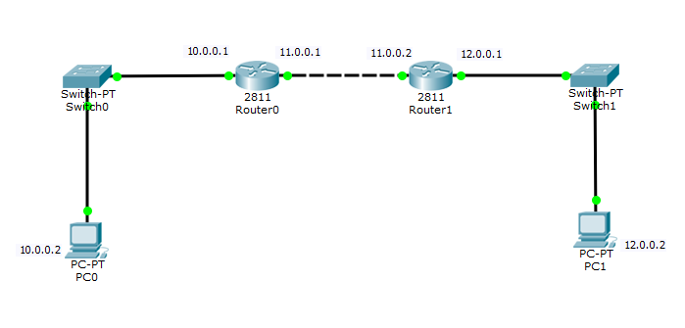

In router 0:
Router(config)#ip route 12.0.0.0 255.0.0.0 11.0.0.2
In router 1:
Router(config)#ip route 10.0.0.0 255.0.0.0 11.0.0.1

Router 1 configuration
Router(config)#crypto isakmp enable
Router(config)#crypto isakmp policy 1
Router(config-isakmp)#authentication pre-share
Router(config-isakmp)#encryption aes
Router(config-isakmp)#hash sha
Router(config-isakmp)#group 2
Router(config-isakmp)#exit
Router(config)#crypto isakmp key 0 address 11.0.0.1 0.0.0.0
Router(config)#crypto ipsec transform-set hamad esp-aes esp-sha-hmac
Router(config)#crypto ipsec security-association lifetime seconds 86400
Router(config)#ip access-list extended saud
Router(config-ext-nacl)#permit ip 12.0.0.0 0.255.255.255 10.0.0.0 0.255.255.255
Router(config-ext-nacl)#exit
Router(config)#crypto map auda 100 ipsec-isakmp
Router(config-crypto-map)#match address saud
Router(config-crypto-map)#set peer 11.0.0.1
Router(config-crypto-map)#set pfs group2
Router(config-crypto-map)#set transform-set hamad
Router(config-crypto-map)#ex
Router(config)#int fa 0/1
Router(config-if)#crypto map auda
Router(config-if)#do wr
Router 0 configuration

Router(config)#crypto isakmp enable
Router(config)#crypto isakmp policy 1
Router(config-isakmp)#authentication pre-share
Router(config-isakmp)#encryption aes
Router(config-isakmp)#hash sha
Router(config-isakmp)#group 2
Router(config-isakmp)#exit
Router(config)#crypto isakmp key 0 address 11.0.0.2 0.0.0.0
Router(config)#crypto ipsec transform-set hamad esp-aes esp-sha-hmac
Router(config)#crypto ipsec security-association lifetime seconds 86400
Router(config)#ip access-list extended saud
Router(config-ext-nacl)#permit ip 10.0.0.0 0.255.255.255 12.0.0.0 0.255.255.255
Router(config-ext-nacl)#exit
Router(config)#crypto map auda 100 ipsec-isakmp
Router(config-crypto-map)#match address saud
Router(config-crypto-map)#set peer 11.0.0.2
Router(config-crypto-map)#set pfs group2
Router(config-crypto-map)#set transform-set hamad
Router(config-crypto-map)#ex
Router(config)#int fa 0/1
Router(config-if)#crypto map auda
Router(config-if)#do wr

Test :

Router#show crypto Isakmp policy

Router#show crypto map

