Firewall
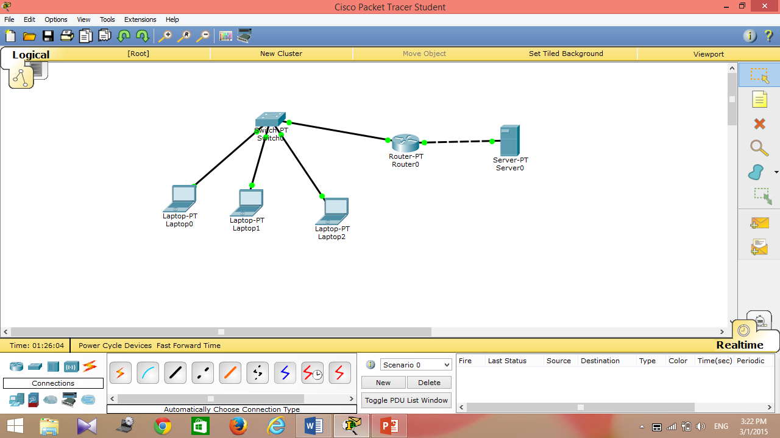
- Open the packet tracer.
- Add 3 laptops, switch, router and server.
- Link all the devices together.
- Chang the Gateway for all laptops to : 192.168.1.1
- Change the following setting for each laptop:
Laptop1:
IP address 192.168.1.11
Subnet mask 255.255.255.0
Laptop2:
IP address 192.168.1.12
Subnet mask 255.255.255.0
Laptop3:
IP address 192.168.1.13
Subnet mask 255.255.255.0
- In the router change the IP configuration for each interface:
Interface 0:
IP address 192.168.1.1
Subnet mask 255.255.255.0
Port Status: ON
Interface 1:
IP address 10.10.10.11
Subnet mask 255.0.0.0
Port Status: ON
- In the Server change the following setting:
Gateway 10.10.10.11
IP Address 10.10.10.128
Subnet Mask 255.0.0.0
Port Status: ON
- From laptop 1 :
Ping laptop2 and the server.
- In the Router Command Line Interface write the following command:
access-list 101 deny icmp any any host-unreachable
access-list 101 permit tcp any any eq www
interface fastethernet0/0
ip access-group 101 in
- From laptop 1 :
Ping the server.
- Use the simulation panel to trace the packet movement.

